## Merchant Name *(AE to fill) : Crew AI* Implementation POC: Jeff *(IM to fill)* CX POC: *[IMP to Add]*

### 

### 

| Notes Sections   *(AE to fill if they have, Implementation to be completion DRI on handoff)*   * Info on how merchant bills Flat billing subscription model today 1) What is the merchant temperament?   Ethan is brand new Head of Finance. Very relaxed and easy to work with. Late 20’s and coming from Okta - new to start up world and very open to working with our team. Rob is COO and EB. Only wanted to discuss commercials. Will not be a daily user - weird guy. 3) What are the Tabs features that the key POC cares about?   * Stripe: Currently used for sending invoices and collecting payments. * QuickBooks Online (QBO): Their current general ledger. * HubSpot: Used as their CRM but not deeply integrated with finance functions. * Google Drive & Google Sheets: Used for managing contracts and tracking financial data (very manually).   Pain Points:   * Manual invoicing: Heavy reliance on Stripe and spreadsheets without automation. * Messy contract management: Contracts are inconsistently stored in Google Drive. * Delayed billing: Customers have not been properly invoiced; backlog exists. * Lack of HubSpot and QBO integration: No clean visibility or data syncing. * Complex deal structures: Includes odd discounts, custom terms, and messy billing schedules that their current process can't easily manage.   Why Tabs:   * Automation: End-to-end management of invoicing, payment collection, and syncing with QBO and HubSpot. * Contract AI Parsing: Extracts billing terms, ramp-ups, PO requirements, etc. directly from contracts. * Enterprise Complexity Handling: Flexible invoice schedules, PO management, multi-contact invoicing. * Ease of Setup: Rapid implementation possible (~10 business days for initial setup). * Recommended by trusted CFO: Tabs already has credibility with their key external advisor. |
| --- |

### Billing model *(Entire Section: Implementation to fill section)*

* Are there unique things about the customer creation process for this merchant?
* Information on how merchant bills
* How contract is broken up
* One off things to know about the merchant

### Contract Processing Steps *(Entire Section: Implementation/Success to fill Post-Go Live)*

1. Steps to process

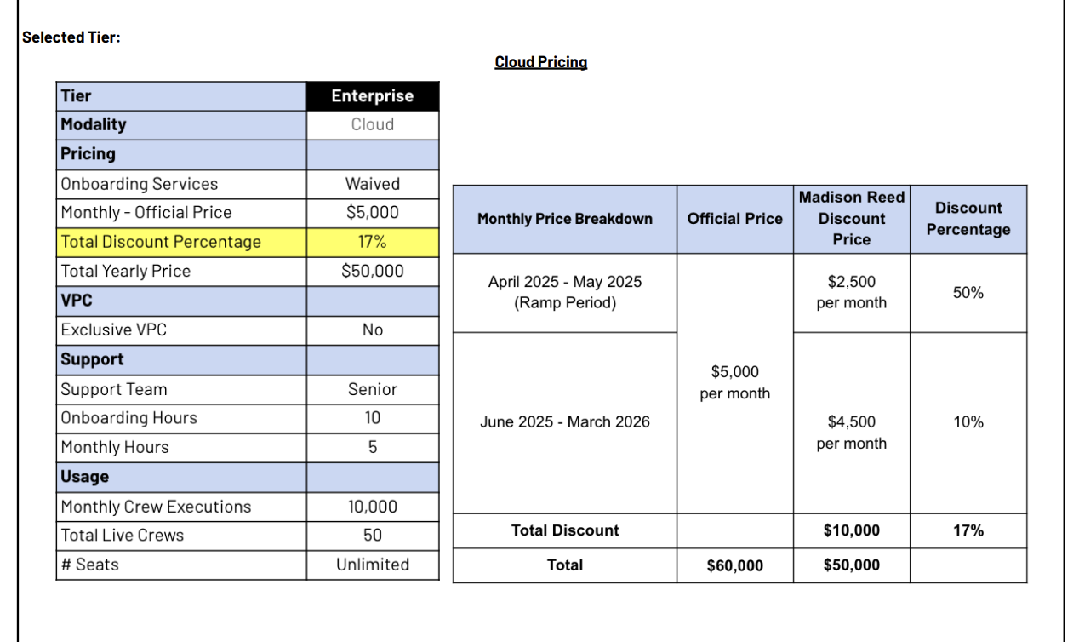  
**Service start date:** use the “term of the agreement” start date. If not stated, use the signature date

**Months of Service:** calculate the number of months between the service start date and the agreement end date

**Item Name:** Use the title of the table + the tier e.g. “Enterprise Cloud Pricing”

Item Description: list detailed product characteristics e.g.

* 10 onboarding hours
* 4 monthly hours
* 10,000 monthly crew executions
* 50 total live crews
* Unlimited seats

**Billing Type:** Flat

**Total Price:** Populate based on discount and discount period in the pricing table (example shown above)

* Create separate billing terms if discount is not applied uniformly like in the example above. Revenue recognition period should always be the same months of service but billing period will vary
* In the example below, the discount is applied uniformly (same across the term of the agreement) so only one BT is required

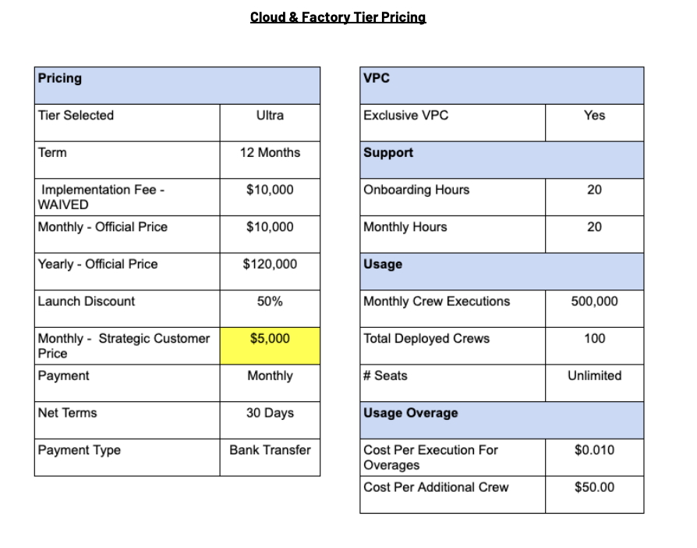

**Quantity:** Default 1 for the platform subscription, unless stated otherwise

**Billing Start Date:** Service Start Date

**Frequency:** default one month, unless stated otherwise

**Periods:** use number of months between start and end date

1. Anything to ignore in contracts?
2. Specifics processing things the merchant has requested that may differ by contract (e.g. always back-date invoice date to final day of the month)
3. Default Service Term
   1. If None Listed, Ops Default is 1 Year
4. Default Net Payment Terms
   1. If None, Ops Default is 0
5. Default Billing Frequency
   1. If None Listed, Ops Default is Monthly
6. How do we handle taxes as a line item?
   1. If None Listed, Ops Default is every tax line item becomes a BT

### Events Processing (if necessary) *(Entire Section: Implementation/Success to fill Post-Go Live)*

* Any important information on events billing

Integration Items Processing (if necessary)  
*(Entire Section: Implementation/Success to fill Post-Go Live)*

* What are the instructions for assigning integration items?
* Example: All Statsig integrations items should be labeled as “Sales”
* Example: All “Pinata” integration items should be labeled as “Software Subscription Bundle” unless otherwise noted by Merchant

Post Processing Communications (if necessary)  
*(Entire Section: Implementation/Success to fill Post-Go Live)*

* Does the Ops Team need to notify anyone on the team re: completion of processing batches in Implementation or Active phase?
* Who needs to be notified and when?
  + Example:
    - Who: Customer Success [Azmat Aziz] needs to be notified
    - Where: Messari internal merchant channel
    - When: contracts are processed [Merchant Phase: Active]

### Customer Information *(Entire Section: Implementation/Success to fill Post-Go Live)*

* Any important information on specifics customers of this merchant
  + Special memo’s certain invoices require
  + Invoice changes due to merchant/customer relationship

### Feature Requests *(AE to fill for all requests prior to Imp handoff, Imp to fill prior to go-live/Success to fill to fill Post-Go Live)*

* FR 1
  + What is it
  + Why it's important
  + Urgency

### Merchant Calls *(AE to fill for all videos prior to Imp involvement, Imp to fill prior to go-live/Success to fill to fill Post-Go Live)*

* Disco 4/28
  + <https://us-56595.app.gong.io/call?id=4165041178677840027>
* Demo/Disco 4/29
  + <https://us-56595.app.gong.io/call?id=7179827422311386721>